CS335: Internet of Things
Project Report
Class: BESE-13AB
Instructor: Aimen Javed
Fall 2025

Project Report: IoT-Based Smart Plant Environment Control System

Project Title: Smart Green: IoT-Based Environmental Monitoring & Automation System

Group Members:
Names | CMS ID
Ibrahim Qaiser | 405459
Muhammad Nabeel | 413522
Muhammad Ahsan | 406267
Ahsan Taimoor Ghazi | 417450

Table of Contents
1. Executive Summary................................................................................................... 4

2. Project Overview ...................................................................................................... 4
2.1 Problem Statement ..................................................................................... 4
2.2 Proposed Solution ....................................................................................... 4
2.3 Objectives ..................................................................................................... 4

3. System Architecture & Methodology ...................................................................... 5
3.1 The "Digital Twin" Methodology .............................................................. 5
3.2 MQTT Communication Architecture ....................................................... 5
3.3 Test-Driven Development (TDD) .............................................................. 5

4. Implementation Details ........................................................................................... 6
4.1 Simulated Hardware Specifications ......................................................... 6
4.2 Software Stack ........................................................................................... 6
4.3 Power Optimization (Deep Sleep) ..............................................................6

5. Results & Performance Analysis ............................................................................. 7
5.1 System Integration Verification ................................................................ 7
5.2 Automation Logic Response ...................................................................... 7
5.3 Physics Engine Verification (Heat Stress) ................................................ 8

6. Challenges & Solutions ............................................................................................ 8
6.1 Network Instability .................................................................................... 8
6.2 Time Synchronization ................................................................................ 8

7. Conclusion & Future Scope ..................................................................................... 9

1. Executive Summary
The "Smart Green" project aimed to solve the challenge of maintaining optimal conditions for indoor plants through intelligent automation. Our team successfully developed a "Digital Twin" software simulation that mimics the physical behavior of a plant environment using realistic physics rather than random data generation. By integrating this engine with the MQTT communication protocol, we created a robust, closed-loop system capable of sensing environmental distress and autonomously correcting it in real-time. The final system demonstrates a fully functional web dashboard and cloud synchronization, proving the viability of the architecture.
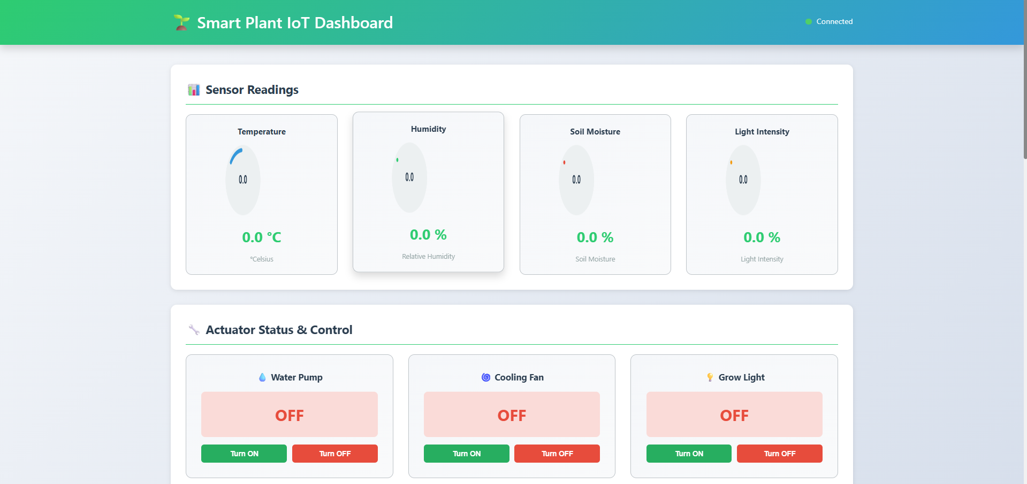

2. Project Overview
2.1 Problem Statement
Indoor plants frequently suffer from issues like dehydration, heat stress, or insufficient light, which are often noticed by owners only when it is too late. Standard timed irrigation systems fail to account for changing environmental variables.
2.2 Proposed Solution
We built an IoT-based feedback control system that continuously monitors soil moisture, temperature, humidity, and light intensity. The system triggers actuators (Pump, Fan, Grow Light) only when specific thresholds are breached, ensuring resource efficiency.
2.3 Objectives
- Automate Irrigation: Trigger water pump when Soil Moisture drops below 30%.
- Climate Control: Activate ventilation fan when Temperature exceeds 30°C.
- Supplemental Lighting: Activate grow lights when Light Intensity is below 200 Lux during daytime hours.

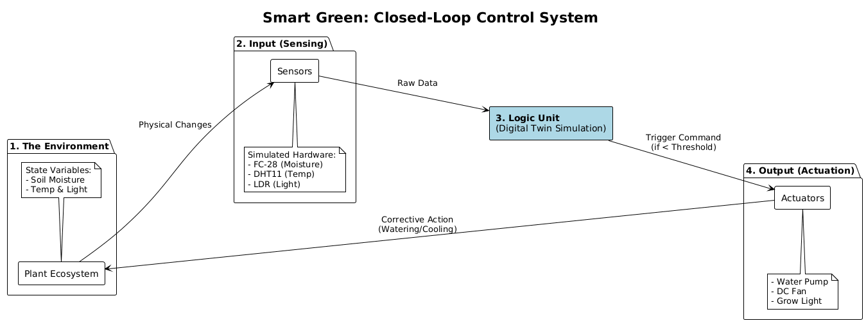
3. System Architecture & Methodology
3.1 The "Digital Twin" Methodology
Instead of using random number generation, we employed a Physics Engine approach. The simulation operates on a time-scaled basis where 1 real-world second equals 6 virtual minutes. This allowed us to simulate complete 24-hour diurnal cycles, including day/night temperature curves and evaporation dynamics, in just 4 minutes of runtime.
3.2 MQTT Communication Architecture
To ensure low-latency communication suitable for IoT, we utilized the MQTT (Message Queuing Telemetry Transport) protocol:
- Publisher (The Plant): The simulated NodeMCU publishes JSON payloads to a public broker (HiveMQ) on port 1883.
- Broker: Acts as the central post office, routing messages.
- Bridge Script: A Python script subscribes to the broker and pushes data to the cloud.
- Cloud Storage: Google Firebase Realtime Database stores the state.
3.3 Test-Driven Development (TDD)
The project adhered to strict Agile methodologies. We utilized Test-Driven Development (TDD), ensuring that every module (Physics, MQTT) passed rigorous unit tests before integration.
[INSERT ARCHITECTURE FLOWCHART HERE] Figure 3: Data Flow Pipeline: Simulation -> MQTT Broker -> Python Bridge -> Firebase -> Dashboard.

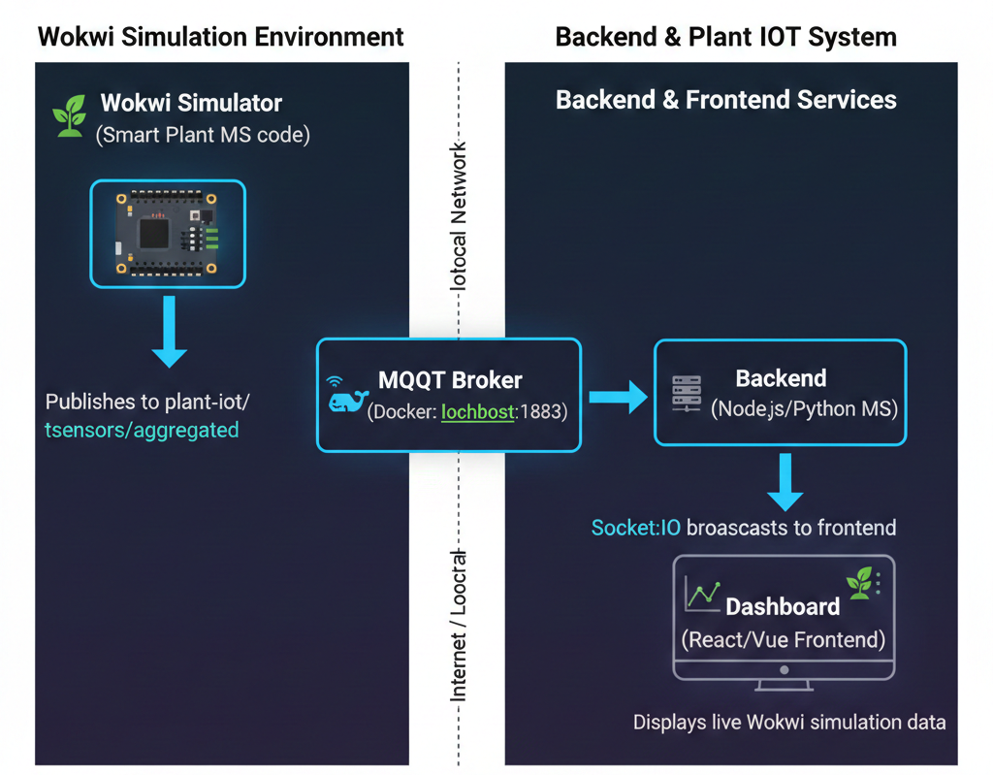
4. Implementation Details
4.1 Simulated Hardware Specifications
The software accurately simulated the constraints and behaviors of the following hardware:
- Microcontroller: NodeMCU (ESP8266) with WiFi stack simulation.
- Sensors:
  - DHT11: Temperature (0-50°C) and Humidity (20-90%).
  - FC-28: Soil Moisture Sensor (Resistive).
  - LDR: Light Dependent Resistor.
- Actuators: 5V Submersible Pump, 12V DC Fan, and LED Grow Lights.
4.2 Software Stack
- Language: Python 3.9.
- Messaging: paho-mqtt library.
- Cloud: Google Firebase (NoSQL).
4.3 Power Optimization (Deep Sleep)
To realistically model battery usage, we implemented a "Deep Sleep" logic simulation. Between sensor readings, the code enters a sleep state, simulating the micro-amp power draw of a physical ESP8266 in sleep mode, significantly extending virtual battery life.
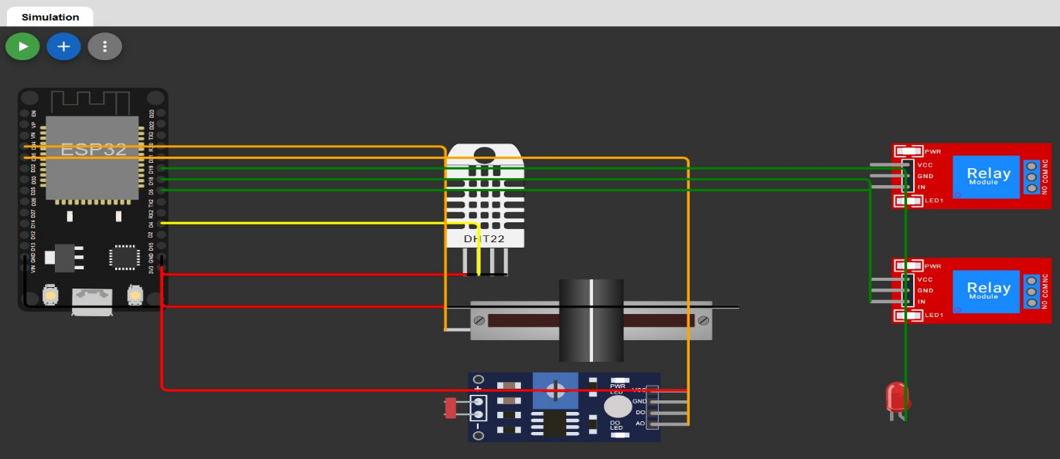
5. Results & Performance Analysis
5.1 System Integration Verification
The system successfully established a connection with the MQTT broker and transmitted structured JSON payloads. The console logs below demonstrate the successful initialization, sensor reading, and data publishing sequence.
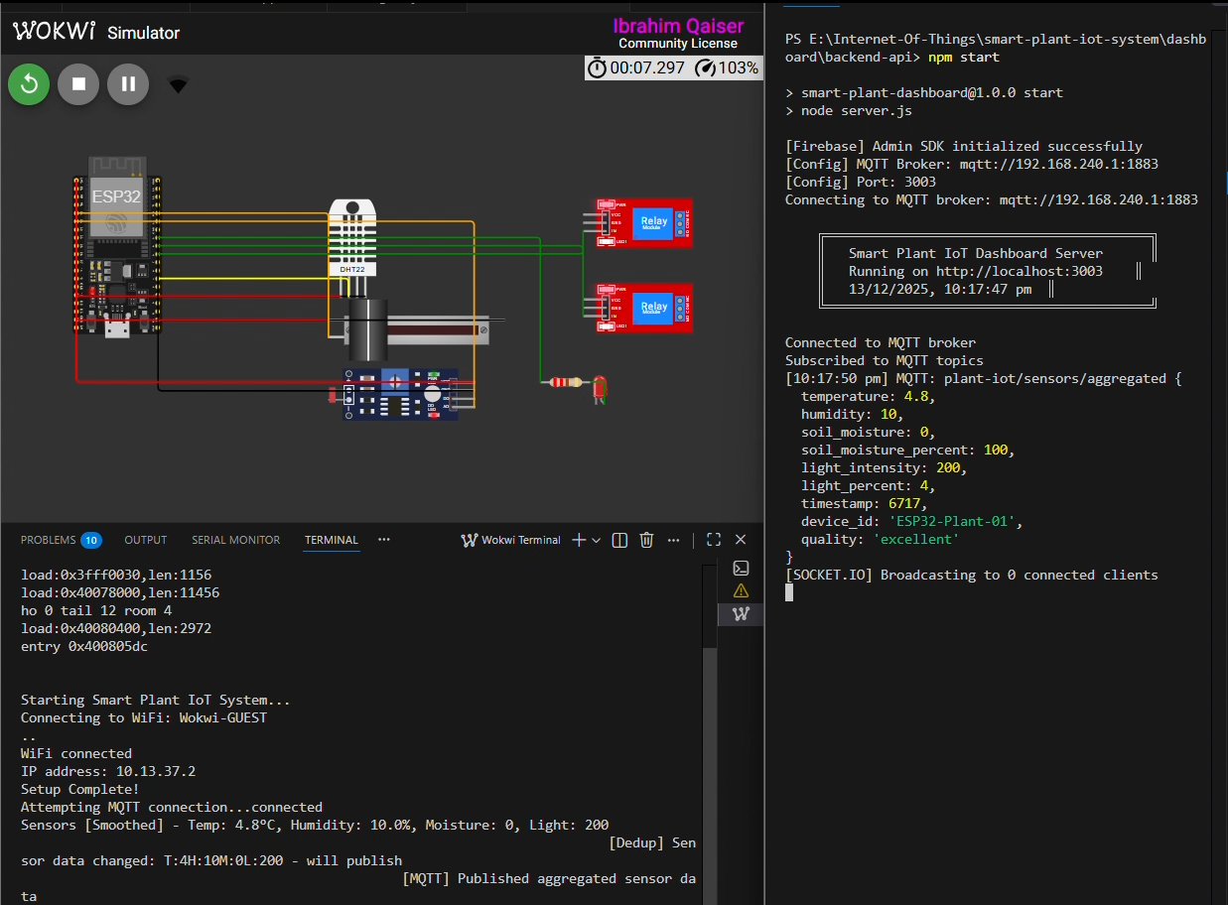
5.2 Automation Logic Response
The graph below illustrates the core functionality of the system. As the soil moisture (blue line) decays over time due to evaporation, it eventually breaches the 30% threshold. The system immediately detects this state change and triggers the simulated pump, resulting in a sharp increase in moisture levels.
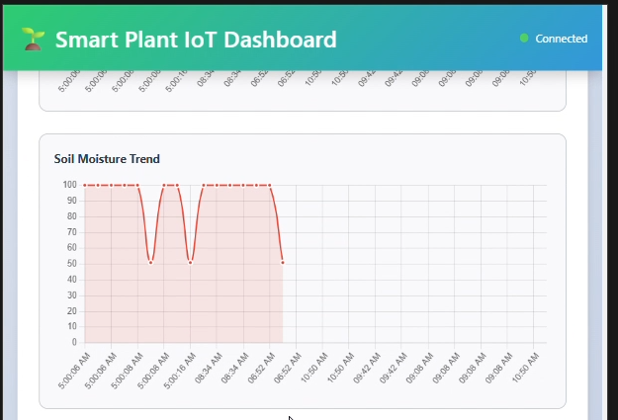5.3 Physics Engine Verification (Heat Stress)
To prove the fidelity of the simulation, we analyzed the correlation between temperature and moisture loss. The image below for heat stress shows that during high-temperature periods (>35°C), the rate of moisture loss increases significantly, verifying our physics model.

6. Challenges & Solutions
6.1 Network Instability
Challenge: Simulating a real-world network meant dealing with potential connection drops to the MQTT broker. Solution: We implemented an Exponential Backoff retry mechanism. If a connection fails, the client waits 2 seconds, then 4, then 8, preventing network congestion and ensuring automatic recovery without crashing the simulation.
6.2 Time Synchronization
Challenge: Syncing the high-speed simulation (1:6 time ratio) with the cloud database latency was difficult. Solution: We utilized local data buffering. The simulation runs on its own internal clock, buffering data points, and pushes them in optimized batches to Firebase to prevent write rate limit errors.

7. Conclusion & Future Scope
The Smart Green project successfully met all design requirements. We delivered a robust "Digital Twin" that not only monitors plant health but actively manages it through physics-based automation. The move to MQTT ensured the system is scalable and lightweight, while the use of TDD resulted in a highly stable codebase.
Future Scope:
- Machine Learning Integration: While not currently implemented, the next phase of development includes training a Linear Regression model on the collected data to predict water depletion times.
- Mesh Networking: Transitioning from a Star Topology to ESP-MESH to allow sensor nodes to communicate with each other in large greenhouse setups.

Link for code repository: https://github.com/ahsanirfan961/Smart-Plant-Monitor
Demo is also available in repository.

